CONTAINER SHIPMENT NEEDS

Dear PeaceWorks Friends,

During its recent trip to Nicaragua, the PeaceWorks Delegation met with each of our Nicaragua Partners and discussed, among other things, our container shipments. Specifically, we discussed:

- the value to our Partners of the materials received in shipments
- items that the partners would like to receive in future shipments
- the process used in the shipments

Our Partners all said the shipments were of great value for them, both in terms of the materials received and the solidarity that the shipments represent with the PeaceWorks community. All wished that the shipments continue. The most common request was “more”. It was heartwarming to see items that we sent in past shipments in active use by the people in Nicaragua: bicycles and gardening tools in use in poor villages; fabric sent sewn into costumes for the girls of Inhijambia or items for sale by the Axayacatl sewing collective, often on sewing machines we sent; school supplies being used to help educate street children; and more.

PeaceWorks will continue our tradition of two container shipments each year. The first shipment will be loaded on May 9 at the Presbyterian Church in Plainfield. The second is tentatively planned for October 10. Please continue to collect items for the shipments, using the guidance below. Also, please let us know if you can help with the container loading on May 9, or can help with the pre-loading work in the months between now and May 9 – boxing and labeling collected materials and moving them to our storage location. This pre-load help is especially needed! Let Jason Hammond, our shipment coordinator, know how you are willing to help – his email is jhammond@drew.edu

Thanks, John Keith

GENERAL ITEMS TO COLLECT

Types of items that our Partners would like in the shipment are similar to past guidance:

- Bicycles – mountain, bmx, childrens (not road bikes or fancy carbon frame bikes)
- Sewing machines and supplies (needles, thread, spare parts for machines)
- Fabric – for clothing and costumes
- School supplies – notebooks, pens, calculators, etc.
- Art supplies for children and teens
- Sports equipment – especially for baseball, soccer and basketball
- Linens, blankets, towels, table cloths
- Clothing – summer weight. Please sort and label by type - women, girls, mens, boys, baby
- Shoes – particularly for women and girls (sandals, sneakers, nicer shoes) but also men, boys
- Wheelchairs
- Canes, crutches - particularly canes
- Medical supplies – bandages, cast supplies, blood pressure cuffs, thermometers, etc.
- Kitchen items – pots, implements, eating utensils, etc. No glass or ceramic items.
- Gardening tools – heavy duty – shovels, hoes, rakes, wheelbarrows, etc.
- Carpentry tools – screwdrivers, hammers, wrenches, chisels, saws (hack and wood), planes, etc.
- Electronics – lap top computers, printers, flat screen monitors – recent, with memories erased
- Simple electronic cameras (point and shoot, not SLR, recent)
- Electric fans

A few cautions:
- Please make sure that all items are in good working condition; clothing in poor condition or electrical or mechanical items that do not work only create waste that must be sorted out and disposed of either in New Jersey or by our Partners in Nicaragua.
- Send no medicines of any type – not prescription, over-the-counter, vitamins, liquids, pills, whatever – neither separate or mixed in with other items. Medicines are a red flag for Nicaragua customs. Also, send no liquids of any type.
- Any electronics (computers, tablets, printers, monitors) must be of recent vintage, working and able to handle recent versions of key programs such as Microsoft Office. Clean all memories before sending. Pack well in boxes with other stuff, such as clothing.
- In general, do not sent items that look like they may be for re-sale in Nicaragua. Used items are all OK. Do not send commercial scale quantities of new items, such as a carton of notebooks in an original Staples box.
- Please do not sent electrical appliances, machines or gadgets except as listed below.

Specific Items Requested by Partners

Our partners identified some specific items they need and would like to receive. If you are able to provide any of these items, please let Jason know prior to the shipment - and thanks!

Jubilee House
- Medical examination table
- Medical lifts for disabled persons
- Eyeglasses – all types and prescriptions (not badly scratched)
Inhijambia
- Zippers for costumes
- Classical (nylon string) guitars (no steel string or electric)
Los Pipitos
- Physical therapy equipment and supplies
- Simple percussion instruments – tambourines, bells, etc.
- Simple toys like duplo blocks or wooden puzzles – not cheap plastic stuff
Cusmapa Association
- Electric carpentry tools – drill, circular saw, polishing machine, brush, router, hand drill set, extension cords
- Electric appliances: blender, beater
- Night tables
- Televisions for dorms (flat screen only)
- Computer for office
- Small photocopy machine

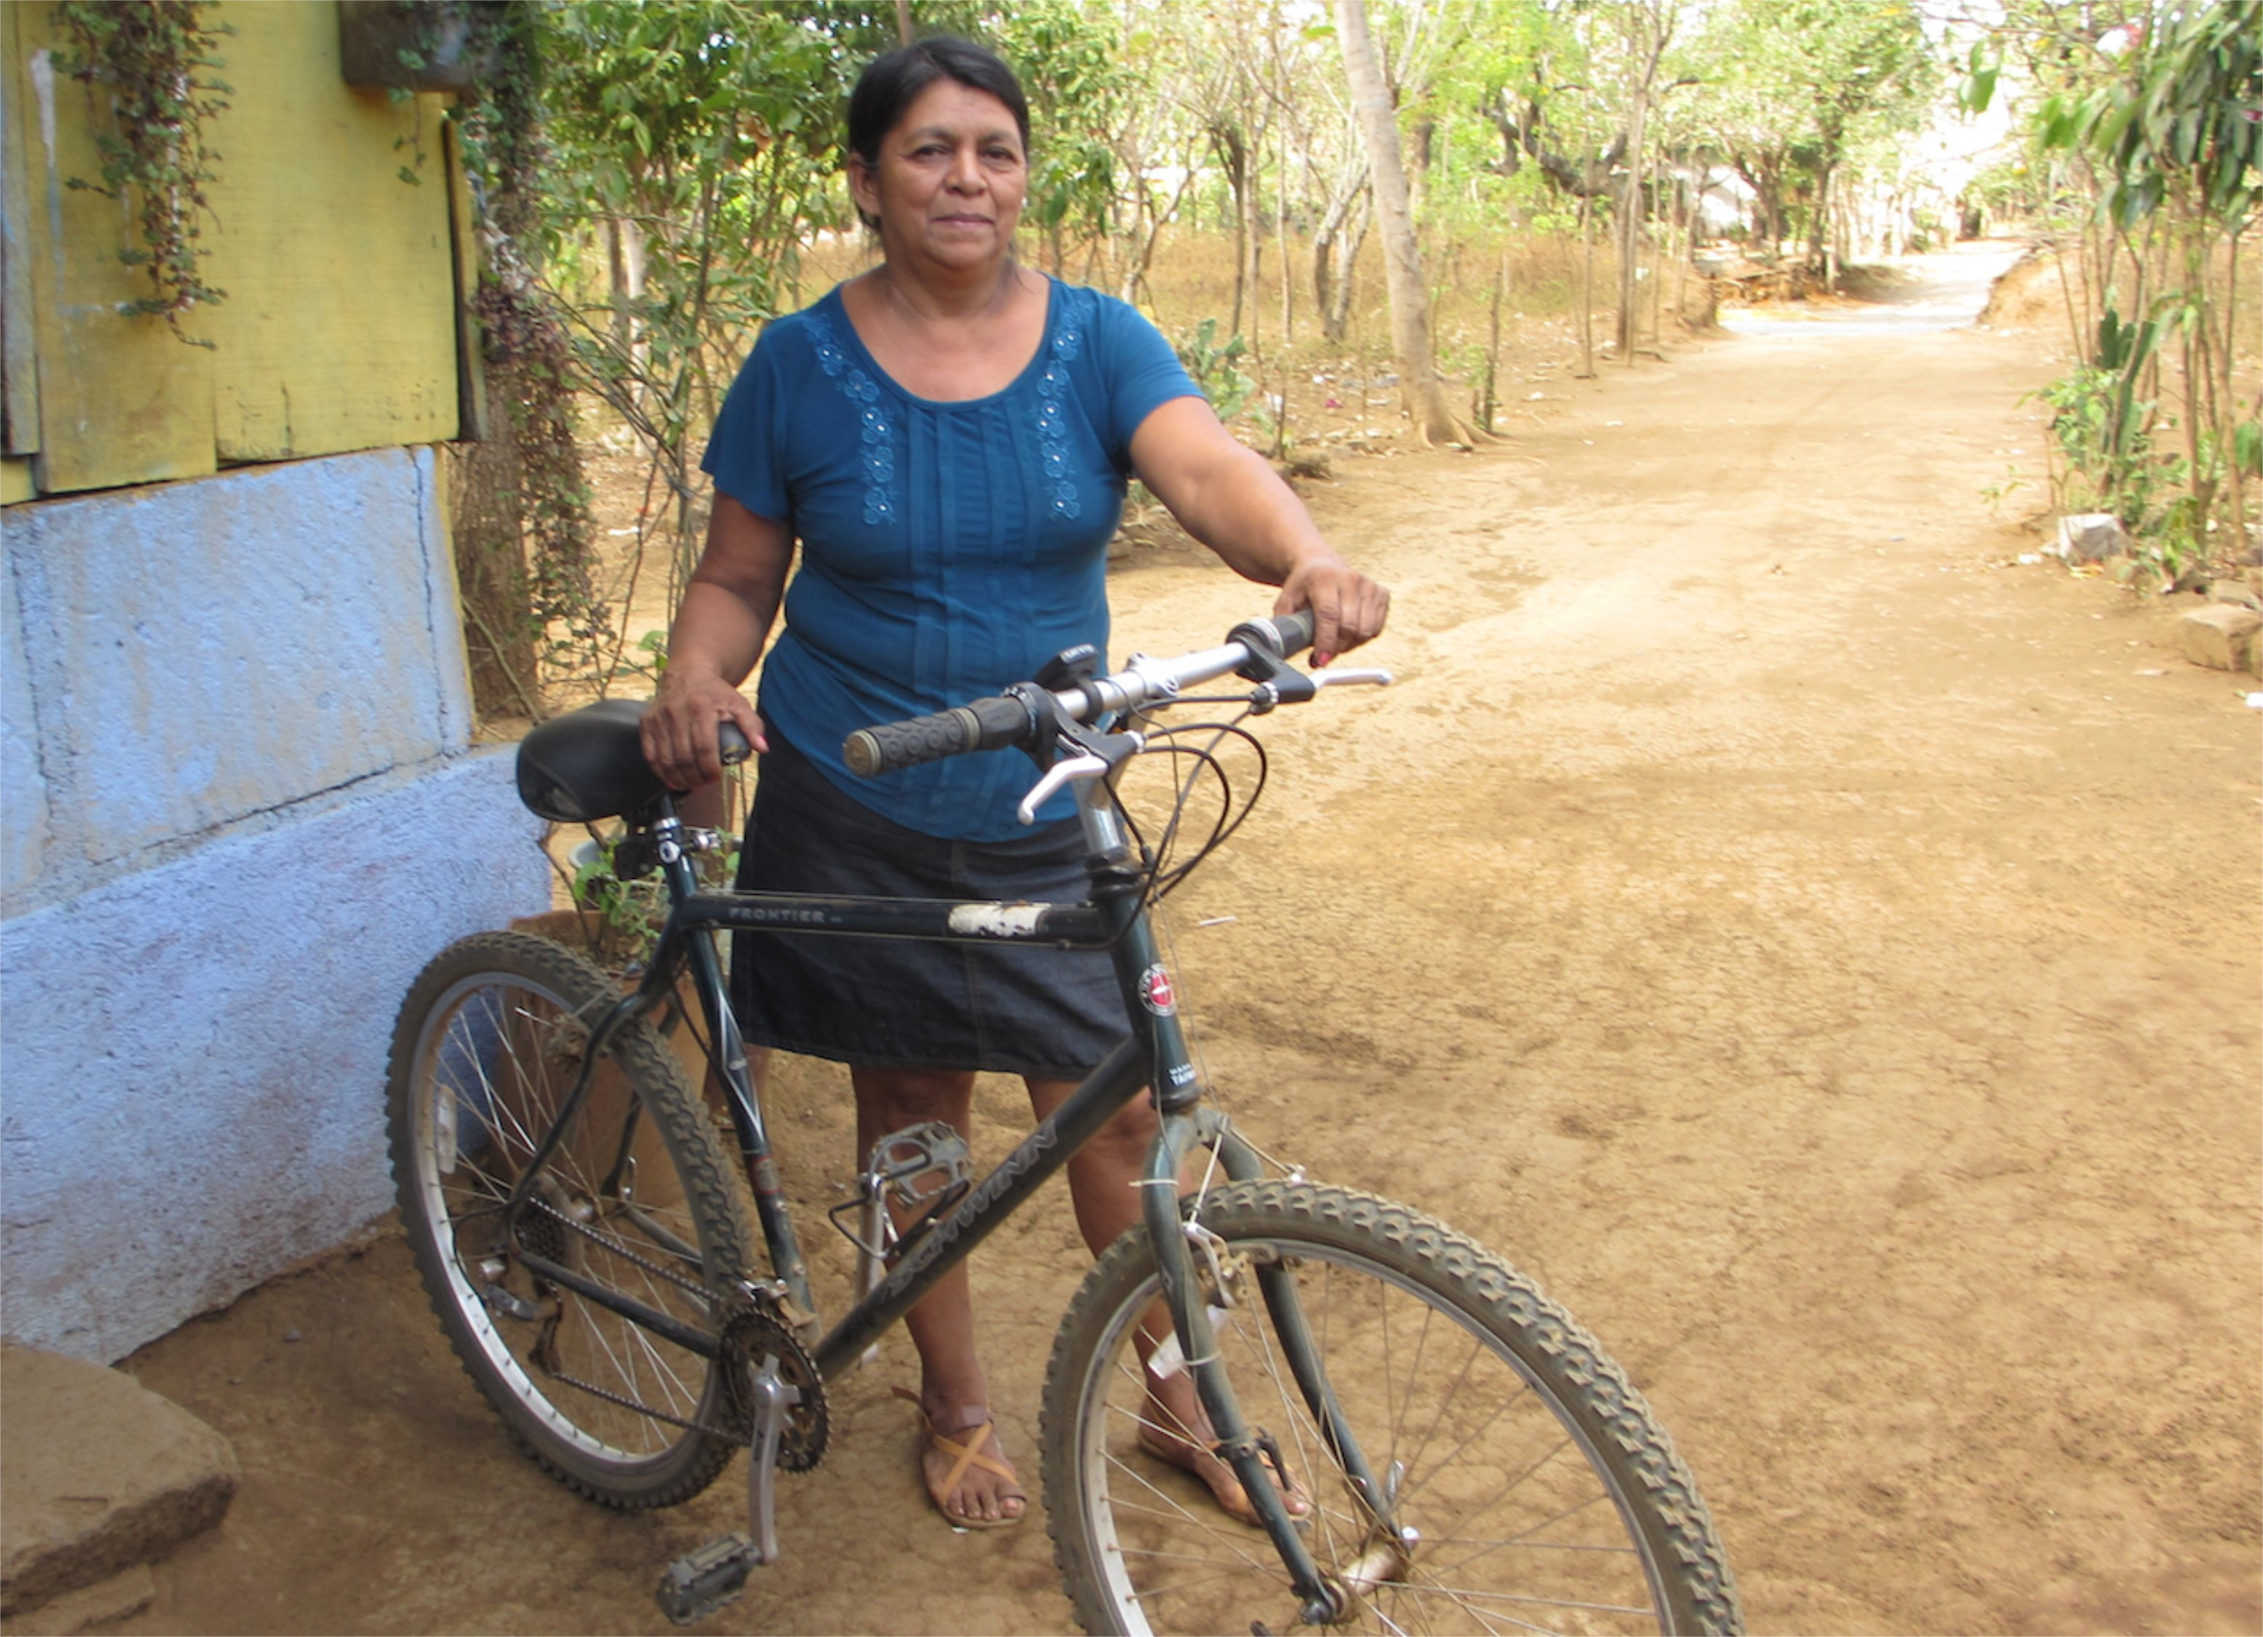
Thanks for your help in collecting items for our shipment!

Fedicamp
- “Chapin” Sprayers for (organic) fertilizers, with attachments – need 15 or so
- 5 gallon plastic pails with covers
- Gardening trays and pots for growing seedlings
- chain link fence – in rolls, 4 ft. high
- 1 inch diameter hose for irrigation systems
- drip irrigation tubing – lots
- Projector for presentations
Cusmapa Pine Needle Collective
- Projector for presentations
El Porvenir
- 2 drawer file cabinet
- Mechanic’s tool box with tools (for tractor)
- Tables for health center, with drawers

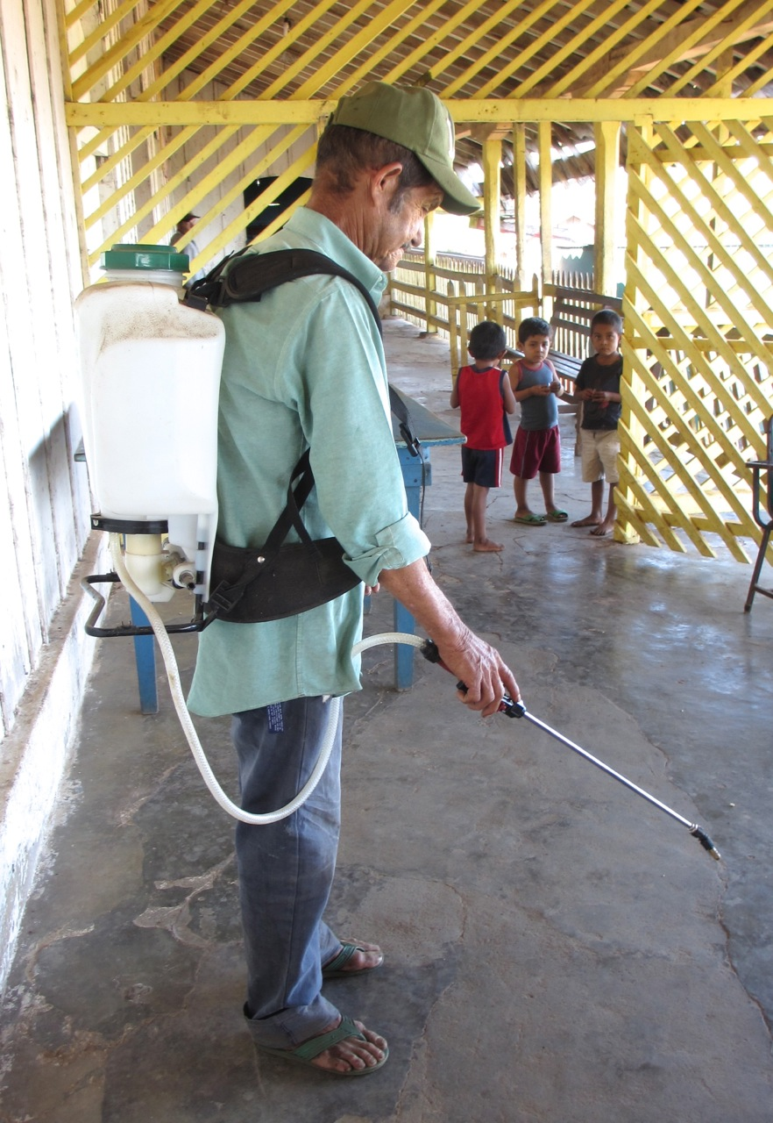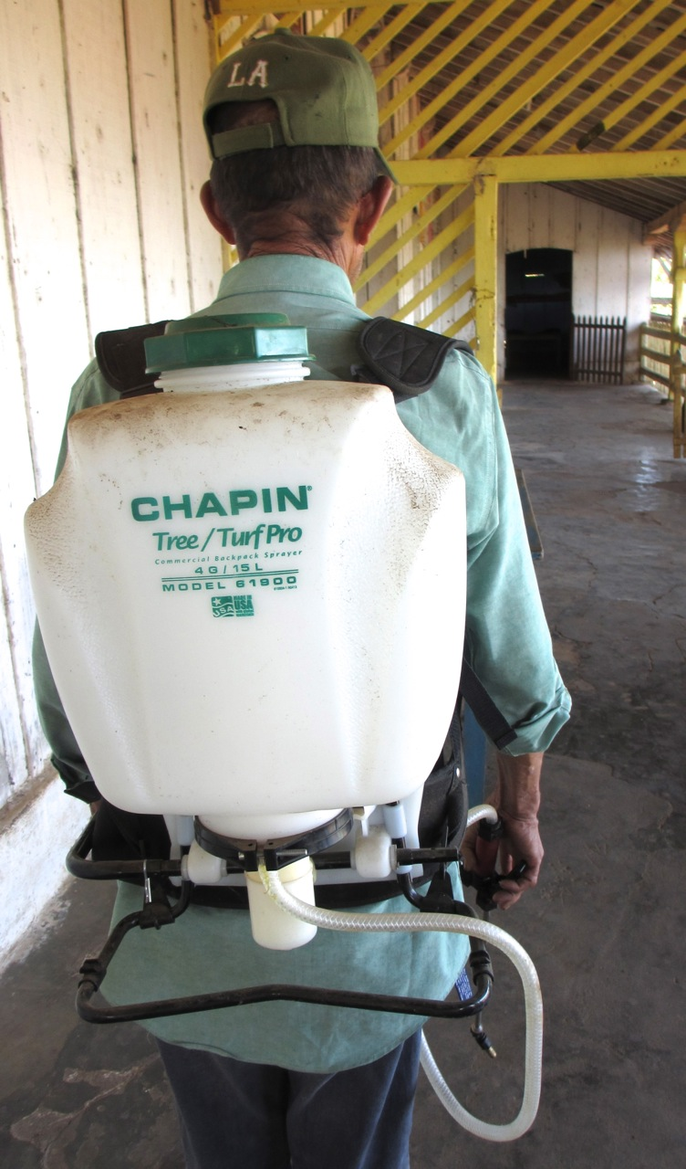
“Chapin” Sprayers needed by Fedicamp and El Porvenir
Bicycle we shipped in use by Axayacatl!

